

“Smart Agriculture Management System”

By

# Soham Pawar : 20230802467

# Satej Pachpute : 20230802466

# Rushiprasad Patil : 20230802434

**Under Guidance Of**

# Dr. Somya Dubey

**Submitted to**

**School of Computer Science, Engineering, and Applications**

**In partial fulfilment of the requirements for the award of the degree**

**Bachelor of Technology (CSE) Year of submission - 2024-25**



**School of Computer Science, Engineering, and Applications**

# CERTIFICATE OF COMPLETION

This is to certify that the project entitled **“Smart Agriculture”** has been completed by **Soham Pawar PRN:20230802467, Satej Pachpute PRN:20230802466, Rushiprasad Patil PRN:20230802434** in partial fulfilment of the Minor Project in the 4th semester B.Tech. (CSE) during the period March - April 2025 as prescribed by **School of Computer Science, Engineering and Applications,**

***D Y Patil International University***, ***Akurdi, Pune.***

**Project Guide Project Coordinator**

**Ms. Akansha Shewale** **Dr. SOMYA DUBEY**

SCSEA, DYPIU, Akurdi, Pune SCSEA, DYPIU, Akurdi, Pune

**Director**

Dr. Rahul Sharma Professor,

SCSEA, DYPIU, Akurdi, Pune

# DECLARATION

I declare that the work contained in this report is original and has been done by me/us under the guidance of my supervisor(s) and the work has not been submitted to any other Institute for any degree or diploma. I have followed the guidelines provided by the **School of Computer Science, Engineering, and Applications, D Y Patil International University** in preparing the report.

**Signature of the Students**

# ABSTRACT

# The Smart Agriculture Management System is a web application created to

# help farmers manage their agriculture in a digital manner. In a time where precision and data-based farming are fast becoming essential, the system fills the gap between the old ways and new technology by creating an easy-to-use and intuitive digital platform.

# The system enables farmers to register, sign in, and enter information regarding their crops such as soil moisture content and consumed resources. This data is safely stored in a MySQL database and can be accessed using a dashboard that enables analysis and decision making. Backend scripting with PHP and frontend development using

# HTML, CSS, and JavaScript guarantee a light but working solution best for small to medium-scale agriculture operations.

# As the demand for efficient agriculture and traceability increases, this system is able to assist farmers in optimizing yield, eliminating waste, and maintaining accurate digital records. The scalable nature of its design can accommodate the addition of future-proof features like IoT sensor inputs and weather forecast APIs, making it an asset in the future of smart agriculture.

**ACKNOWLEDGEMENT**

We take this opportunity to express our deepest sense of gratitude and sincere thanks to everyone who helped us to complete this work successfully. We express our sincere thanks to **Director Dr. Rahul Sharma, School of Computer Science, Engineering, and Applications, D Y Patil International University** for providing us with all the necessary facilities and support.

We would like to express our sincere gratitude to our Faculty Dr. Somya Dubey & Ms. Shobhana Patil Project coordinator, **School of Computer Science, Engineering, and Applications, D Y Patil International University** for the guidance and mentorship throughout this work.

Finally, I thank my family, and friends who contributed to the successful fulfilment of this project work

**Place:Pune Soham Pawar : 20230802467**

**Date:11/04/2025 Satej Pachpute : 2023080246**

**Rushiprasad Patil : 20230802434**

# TABLE OF CONTENTS

|  |  |  |  |  |
| --- | --- | --- | --- | --- |
| Sr.No. | | Title of Chapter | | Page No. |
| 01 | | CHAPTER 1: INTRODUCTION | | 1 |
|  | 1.1 | Introduction | | 2 |
|  | 1.2 | Objectives | | 2 |
|  | 1.3 | Purpose | | 2 |
|  | 1.4 | Project Scope | | 2 |
|  | 1.5 | Applicability | | 2 |
| 02 | | CHAPTER 2: TECHNOLOGY SURVEY AND  SELECTION | | 3 |
| 03 | | CHAPTER 3: REQUIREMENTS AND  ANALYSIS | | 5 |
|  | 3.1 | Problem Definition | | 5 |
|  | 3.2 | Requirements Specification | | 6 |
|  | 3.3 | Software and Hardware Requirements | | 6 |
|  | 3.4 | Conceptual Models/ Design Documents | | 7 |
|  |  | 3.4.1 | a. ER Modelling | 7 |
| 04 | | CHAPTER 4: SYSTEM DESIGN | | 8 |
| 05 | | CHAPTER 5: IMPLEMENTATION AND  TESTING | | 9 |
|  | 5.1 | PseudoCode | | 10 |
| 06 | | CHAPTER 6 : RESULT AND DISCUSSION | | 11 |

|  |  |  |  |
| --- | --- | --- | --- |
|  | 6.1 | Output Screens | 12 |
| 07 | | CHAPTER 7 : CONCLUSION | 13 |
| 08 | | REFERENCES | 14 |

**LIST OF FIGURES**

|  |  |  |
| --- | --- | --- |
| Sr No. | Figure Name | Page no. |
| 1 | ER MODELLING | 7 |
| 2 | SYSTEM DESIGN | 8 |
| 3 | OUTPUT SCREENS | 12 |
|  |  |  |

1

**CHAPTER 1: INTRODUCTION**

**1.1 INTRODUCTION**

The Smart Agriculture Management System is web based platform designed for support of farmers in managing crop information, tracking and keeping a record of resources used and monitoring soil conditions. The project offers a user-friendly interface through which farmers can log in, add new crops, input soil moisture levels, and indicate the inputs utilized for each crop. This information is stored in a securely accessed backend MySQL database, and is accessible through an interactive dashboard for additional analysis and record maintenance.

**1.2 OBJECTIVES**

* To create a digital platform where farmers can register and log in securely.
* To allow farmers to input, update, and review information related to their crops.
* To monitor and record key agricultural data such as soil moisture levels and resources used (fertilizers, water, etc.).
* To store all data securely using a relational database (MySQL).

* To provide an easy-to-use and visually appealing dashboard that displays a farmer's agricultural data.
* To reduce manual errors and improve the accuracy and availability of farm records.

**1.3 PURPOSE**

The objective **Smart Agriculture Management System** is to narrow the gap between conventional farming practices and data-based methods of the present time.  By providing a unified digital platform, the system will make it easier for farmers, particularly those who live far away or in rural locations, to manage agricultural data.

Allowing farmers to view and manage their crop-based data in real-time. Farmers can monitor inputs such as fertilizers, water, and soil using digital record-keeping, which allows them to make informed agronomic decisions. The system is conducive to sustainable agriculture and offers a platform for scalable future developments.

**1.4 PROJECT SCOPE**

The scope of the Smart Agriculture Management System includes designing a responsive, secure, and user-friendly web portal that allows farmers to register, log in, and effectively manage their agricultural information. The system will permit users to input and monitor major parameters like crop names, soil moisture levels, and types and amounts of resources utilized during cultivation.  
  
The platform is meant to be scalable for many users, where the data of every farmer will be stored securely and accessed only by authentication. Also, the system is scalable so that new features can be added in the future, e.g., integrating external sensors or APIs for real-time weather.  
  
The project is centered on small- to medium-sized farming communities and seeks to offer them a technological solution that can enhance farm results and induce smart agriculture practice. Although the present version is web-based, it can be further developed into mobile platforms or IoT-based apps in the future.

**1.5 APPLICABILITY**

The system can be utilized by:

* Farmers seeking to digitize their record-keeping and crop tracking.
* Agricultural institutions that need to manage and monitor field data for research or training.
* Government bodies promoting smart agriculture initiatives.
* NGOs and cooperatives that support sustainable farming practices.

3

**CHAPTER 2: TECHNOLOGY SURVEY AND SELECTION**

|  |  |  |  |
| --- | --- | --- | --- |
| **Technology** | **Category** | **Purpose** | **Reason for Selection** |
| **HTML** | **Frontend** | **Structure and layout of web pages** | **Standard markup language, easy to learn, supported by all browsers** |
| **CSS** | **Frontend** | **Styling and responsiveness of the user interface** | **Customizable styling, supports responsive design** |
| **JavaScript** | **Frontend** | **Adds interactivity and dynamic behavior** | **Enhances user experience with client-side logic, supported across browsers** |
| **PHP** | **Backend** | To handle server-side processing and database logic | Easy to use with MySQL, open-source, and widely supported for web applications |
| **XAMPP** | **Development** | **Locak Development server** | **Includes MySQL and Apache for offline development** |
| **MySQL** | **Database** | To store and manage user and crop data | **Reliable, relational database, fast, easy integration with PHP** |
| **phpMyadmin** | **Database Admin** | **Web interface for MySQL management** | Simple GUI-based management of the database**.** |

**CHAPTER 3: REQUIREMENTS AND ANALYSIS**

#### 3.1 Problem Definition

#### Farmers in rural and semi-urban areas often lack access to digital tools to manage and track their agricultural data. Traditional methods of record-keeping are inefficient, error-prone, and hard to access or analyze. This leads to challenges in decision-making, resource management, and productivity tracking.

#### The Smart Agriculture Management System is designed to provide a digital alternative that simplifies these tasks and brings efficiency to farming operations. It enables users to manage crop-related data securely and allows easy access to past and current data through an intuitive interface.

#### 3.2 Requirements Specification

#### Functional Requirements:

#### User registration and authentication

#### Crop data entry (name, soil moisture, resources used)

#### Dashboard for viewing existing entries

#### Data storage and retrieval from a MySQL database

#### Admin-level control for viewing all data (optional)

#### Non-Functional Requirements:

#### Responsive and user-friendly interface

#### Secure login using password hashing

#### Fast and reliable data access

#### Cross-browser compatibility

#### Scalable design for future improvements

#### 3.3 Software and Hardware Requirements

#### Software:

#### XAMPP (includes Apache, MySQL, PHP)

#### Web Browser (Chrome, Firefox, etc.)

#### Code Editor (VS Code, Sublime Text)

#### Hardware:

#### Laptop/Desktop with minimum 4GB RAM

#### Internet connectivity for resource fetching (optional)

#### Local server environment for testing

#### Hardware Requirements:

● **Processor:** Intel i3 or better  
● **RAM:** 4 GB minimum (8 GB recommended)  
● **Storage:** At least 1 GB (more for heavy log/data files)  
● **Internet:** Required for testing, deployment, and remote access to cloud services

**3.4 CONCEPTUAL MODELS / DESIGN DOCUMENTS**

**3.4.1 ER MODELLING**

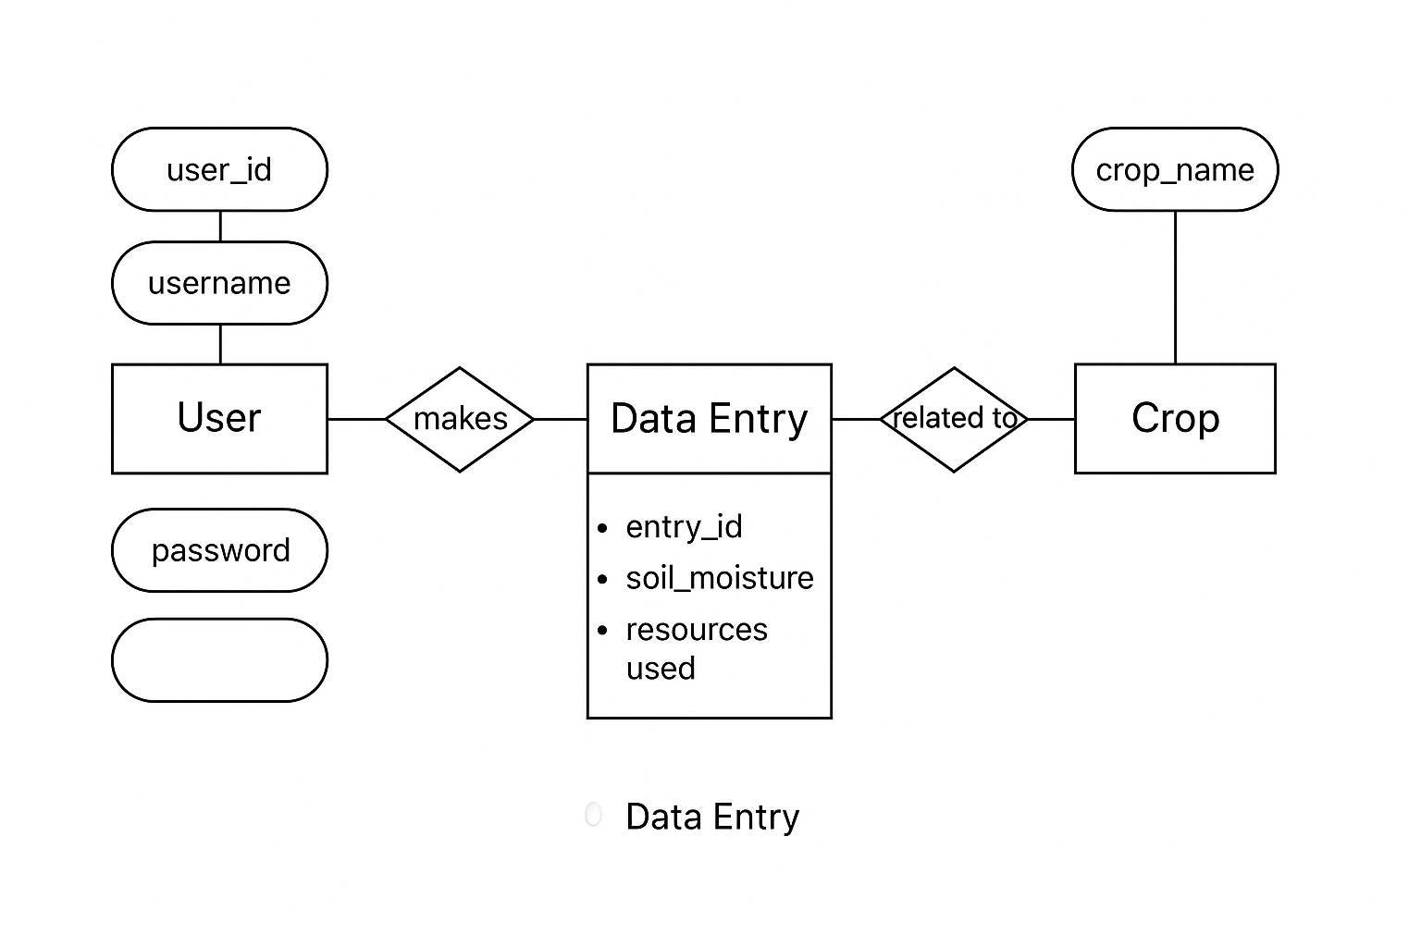



**CHAPTER 4: SYSTEM DESIGN**

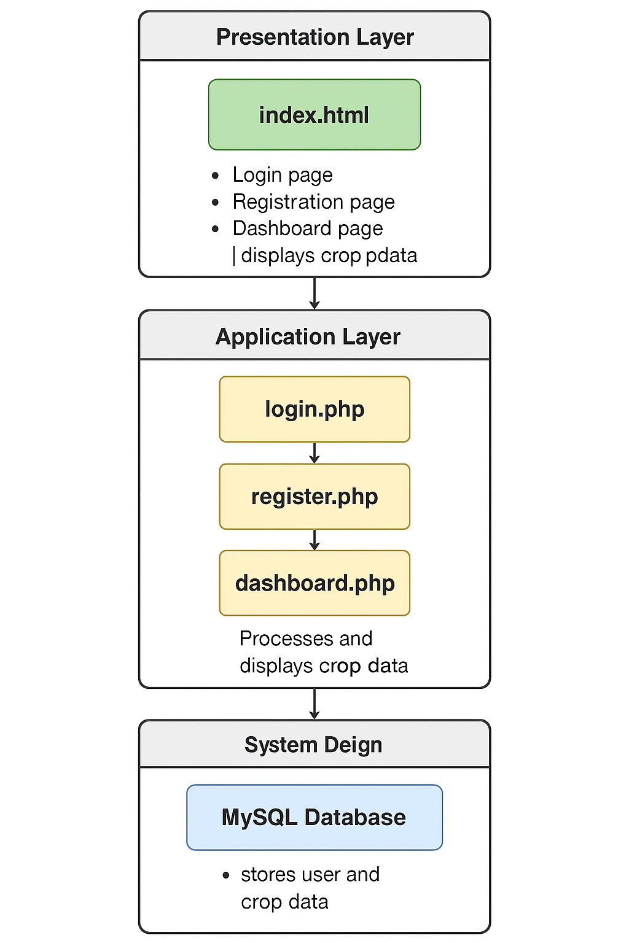

**CHAPTER 5: IMPLEMENTATION AND TESTING**

**5.1 PSEUDO CODE**

**a) User Registration -**

START

IF form is submitted THEN

GET username, email, password from POST

HASH the password

CONNECT to MySQL database

PREPARE SQL INSERT query with user data

EXECUTE query

IF successful THEN

REDIRECT to login page

ELSE

DISPLAY error

END IF

END

**b) User Login**

**START**

**IF login form is submitted THEN**

**GET username and password from POST**

**CONNECT to MySQL database**

**FETCH stored hashed password for username**

**VERIFY entered password with stored hash**

**IF password matches THEN**

**START session**

**REDIRECT to dashboard**

**ELSE**

**DISPLAY invalid credentials**

**END IF**

**END**

**c) Add Crop Data**

**START**

**IF crop form is submitted THEN**

**GET crop name, soil moisture, resources used**

**CONNECT to MySQL database**

**INSERT data into crops table with current user ID**

**REDIRECT or refresh dashboard to display new entry**

**END IF**

**END**

**d) Fetch User Crop Data**

**START**

**CONNECT to MySQL database**

**GET user ID from session**

**FETCH all crop records where user ID matches**

**DISPLAY records in tabular format on dashboard**

**END**

10

**CHAPTER 6 : RESULT AND DISCUSSION**

**6.1 OUTPUT SCREENS**

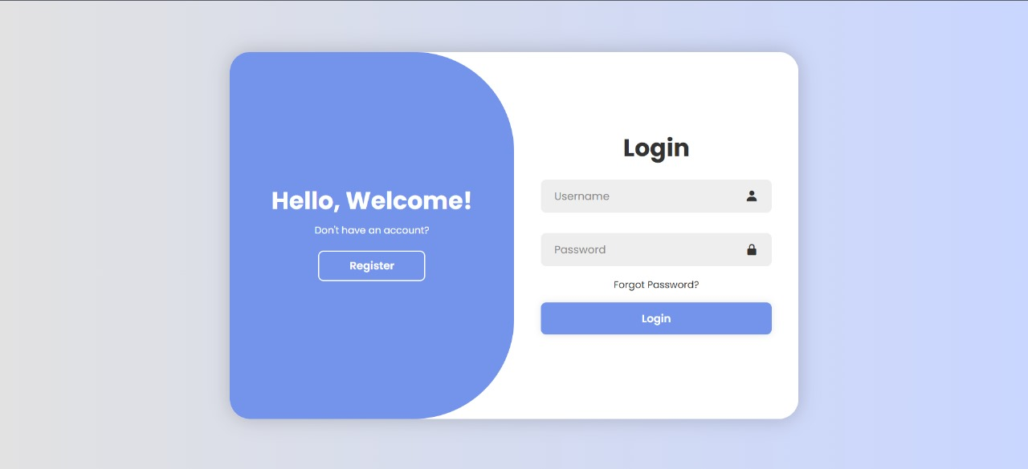

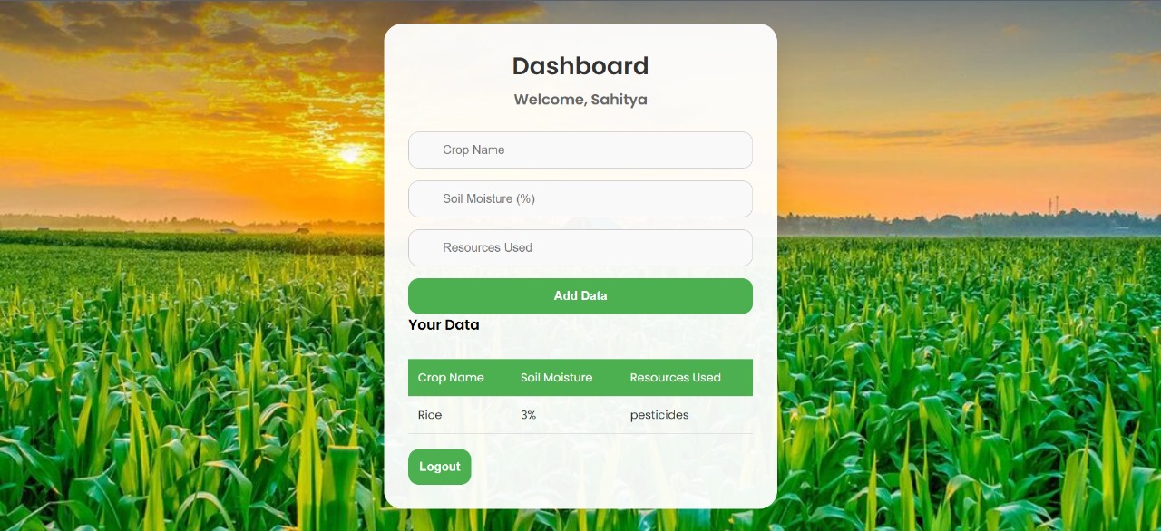

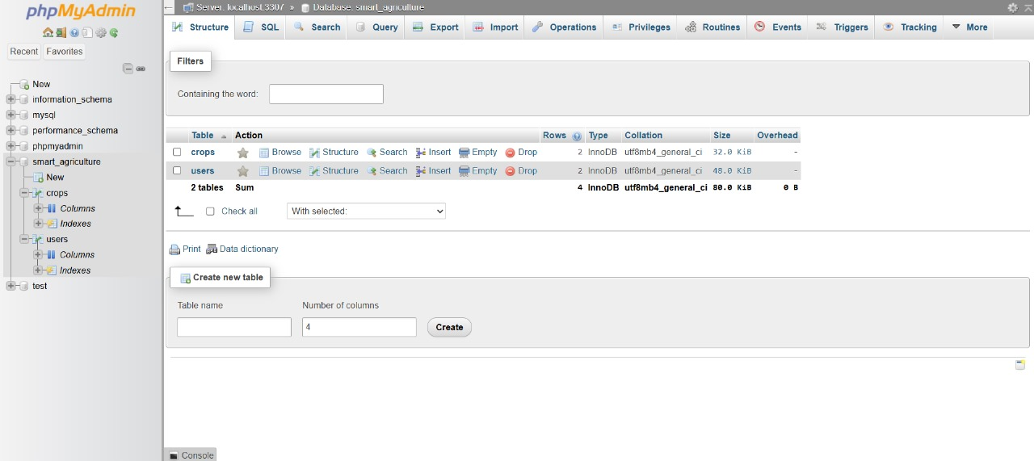

12

### CHAPTER 7: CONCLUSION

The Smart Agriculture Management System offers a practical and efficient solution for digitizing farm data. It enables farmers to easily manage crop records, resource usage, and soil conditions, improving decision-making and reducing manual errors.

With its user-friendly interface and scalable design, the system is well-suited for small and medium-scale farming. Future enhancements like weather integration and mobile access can further improve its impact.

In summary, this project demonstrates how simple web technologies can support smarter, more sustainable agriculture.

### REFERENCES

* **W3Schools - HTML, CSS, JavaScript Tutorials: https://www.w3schools.com/**
* **PHP Manual - Official Documentation: https://www.php.net/manual/en/**
* **MySQL Documentation: https://dev.mysql.com/doc/**
* **Boxicons - Free Icons for Interface Design: https://boxicons.com/**
* **XAMPP - Apache + MySQL + PHP + Perl Installer: https://www.apachefriends.org/**
* **MDN Web Docs - Web Technology Tutorials: https://developer.mozilla.org/**
* **Stack Overflow - Developer Q&A Community:** [**https://stackoverflow.com/**](https://stackoverflow.com/)
* **ChatGPT (for assistance) –** [**https://chatgpt.com/**](https://chatgpt.com/)

14